# Prices

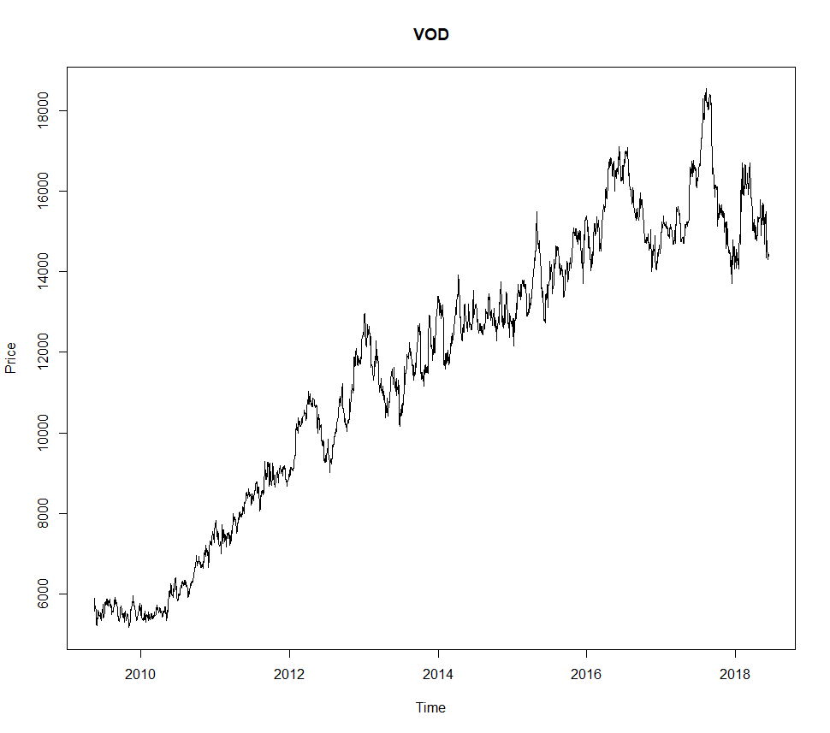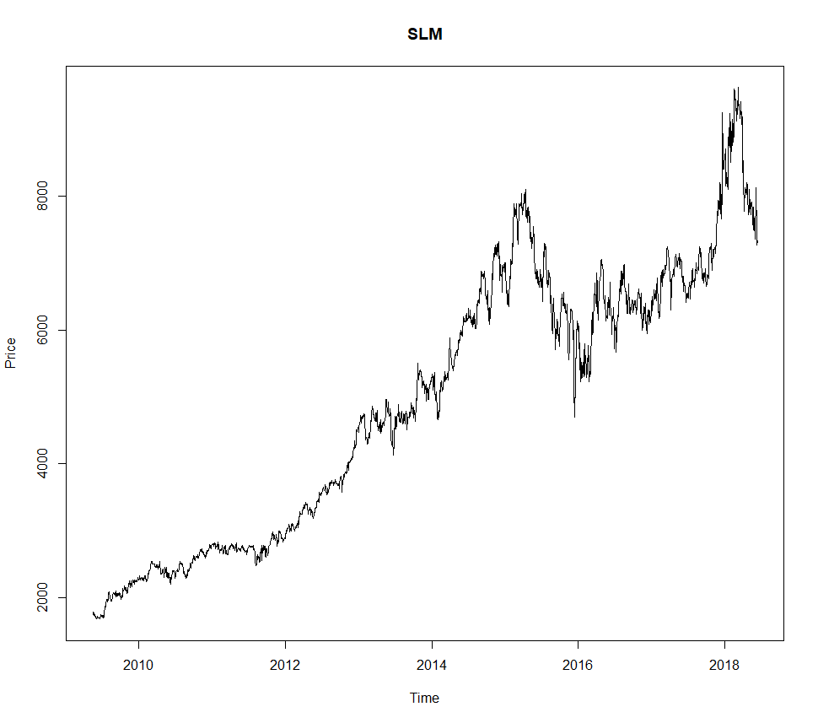

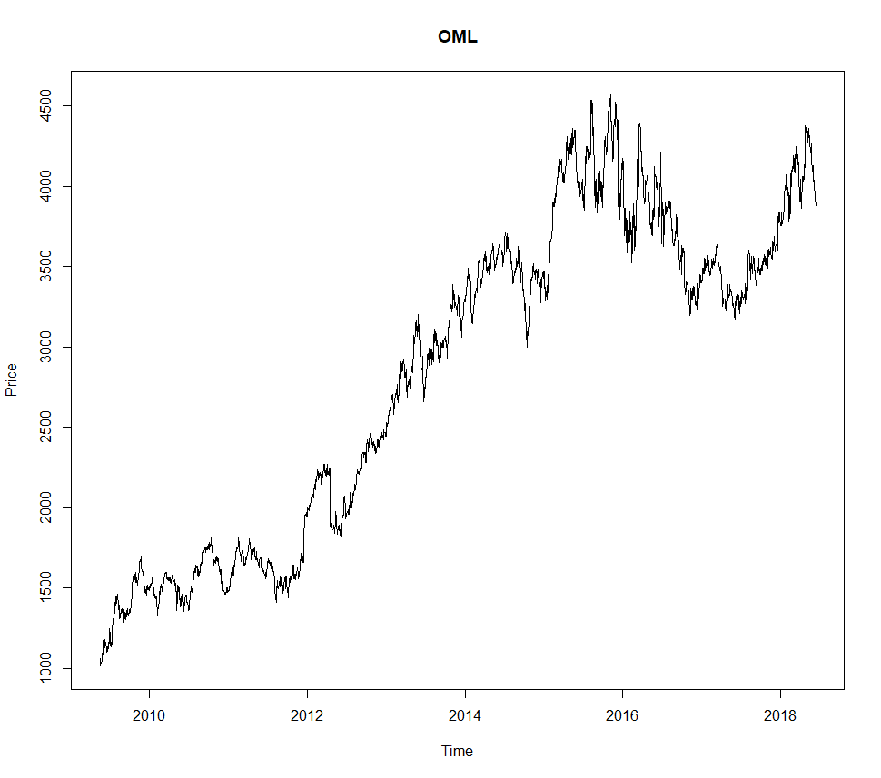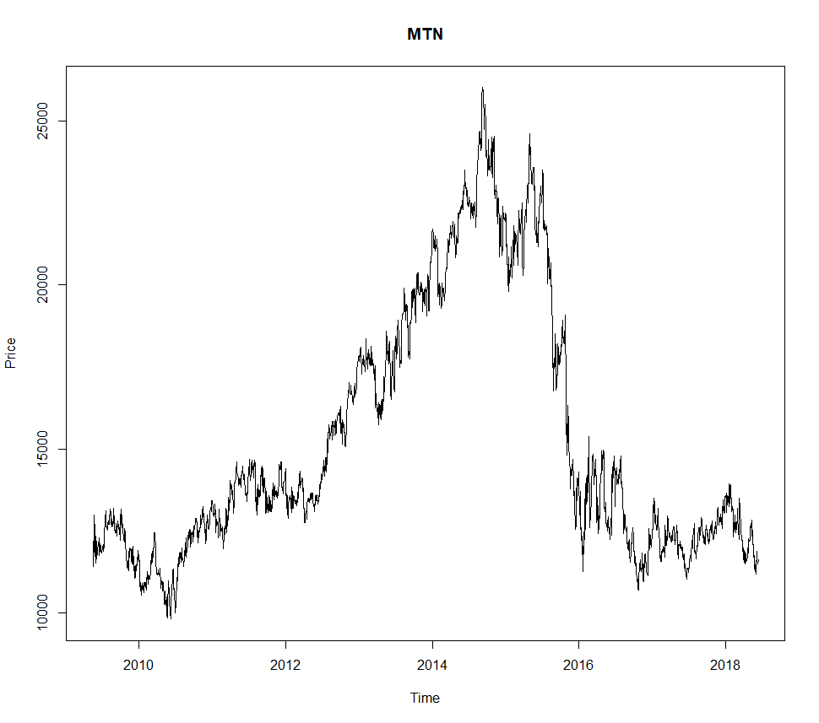

# Optimal value factor weightings

Consider a portfolio which is allocated by considering only value factors:

* Price to book ratio
* Cash flow yield
* Earnings yield
* Dividend yield
* Price to sales ratio

Given a stock’s Sharpe ratio over several days in the future (10 or 22), find the best allocation or weighting to each value factor while considering the other portfolio stocks.

$$\max{F, } F(a,b,c,d,e) := \sum_{i=1}^{4}{S_{i}(aV_{1i}+bV_{2i}+cV_{3i}+dV_{4i}+eV_{5i})}$$

Where Si is the Sharpe ratio of stock i, V1i is the 1st value factor for the i-th stock, and a,b,c,d,e are the coefficients that need to be optimized. Thus, we’re finding best weights for each value factor such that the total Sharpe ratio of the portfolio would be maximized over the following period.

The Sharpe ratio could be exchanged for returns, or for volatility. The objective function would thus change. The weightings can be penalised when they diverge from the default weighting (in this case, 0.2). This is to ensure a smoother transition of weights over time.

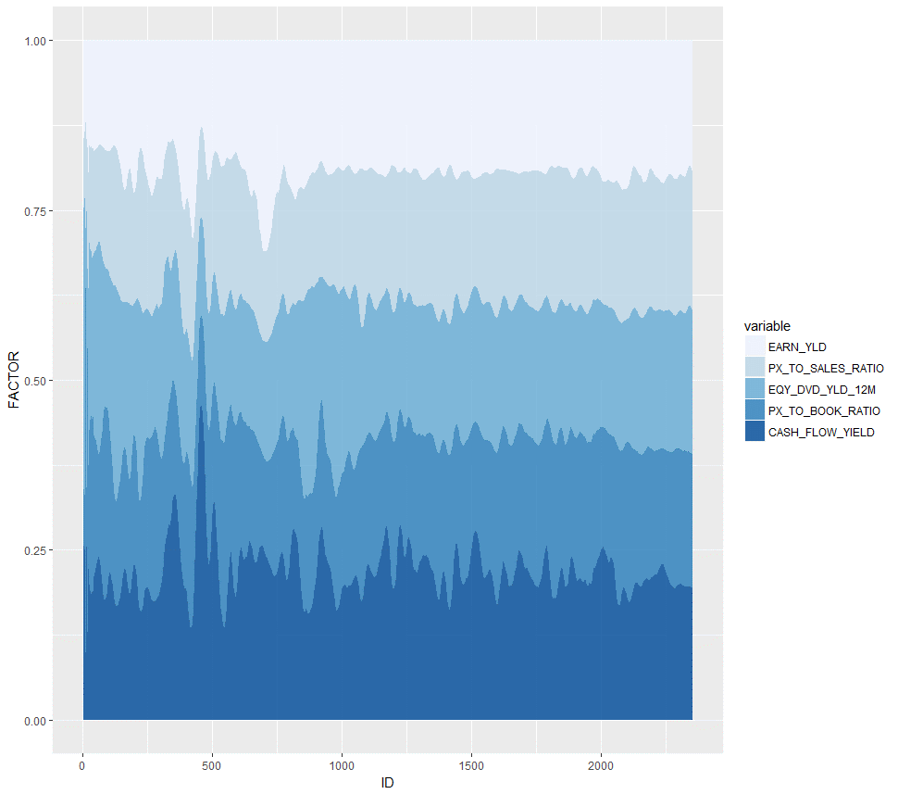

The average Sharpe ratio of the portfolio can be lower or higher than the Sharpe ratio of the optimized portfolio. If it’s lower, it means that the value factors could not distinguish between what would optimize the portfolio. If it’s higher, it means that, on average, the portfolio is more efficient than the default split portfolio.

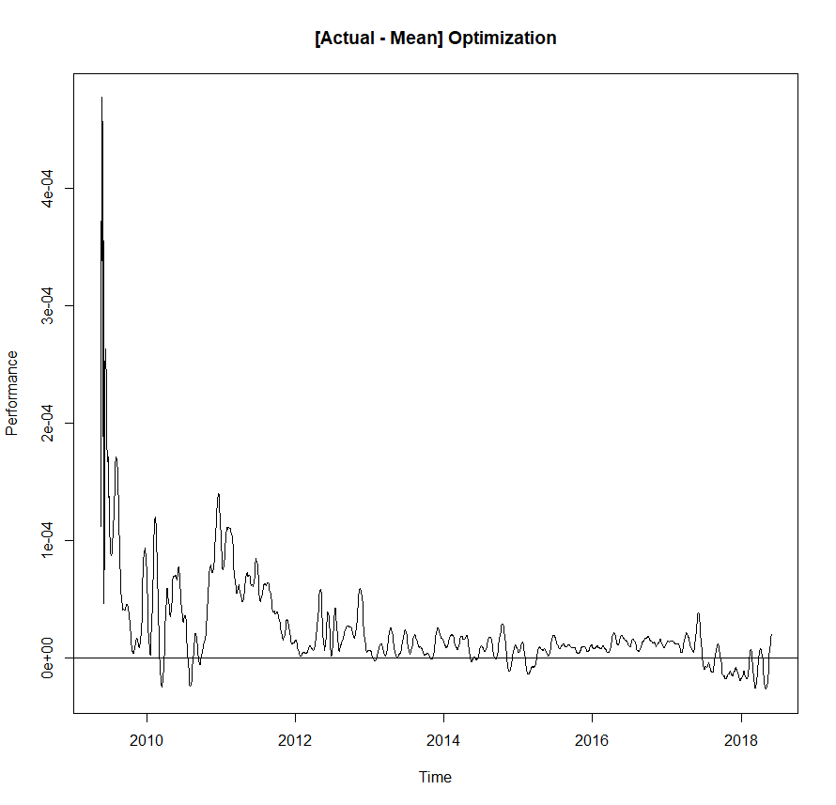

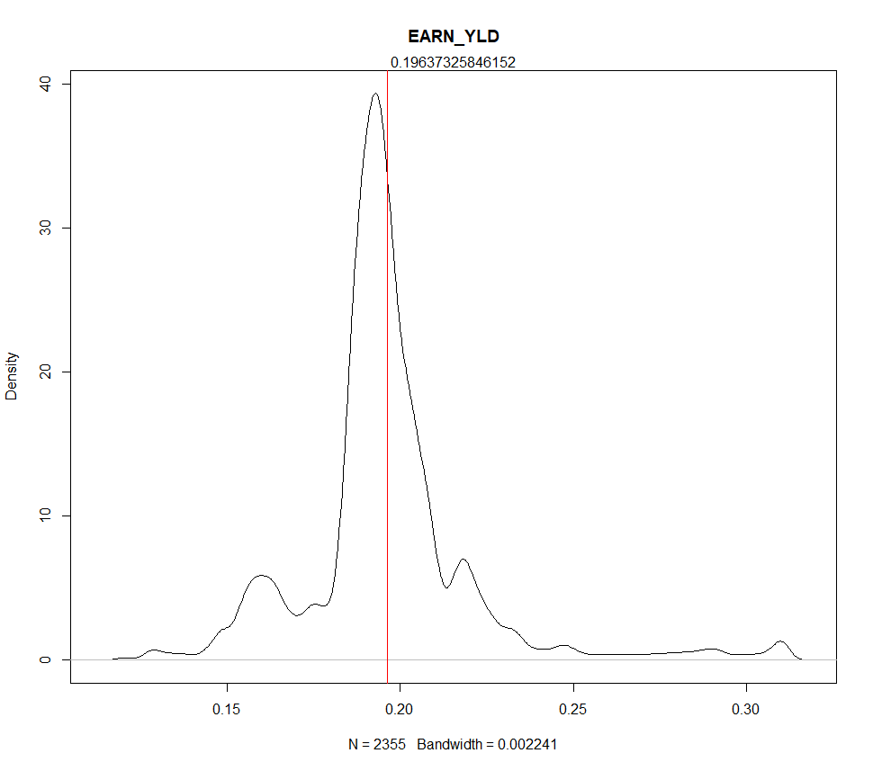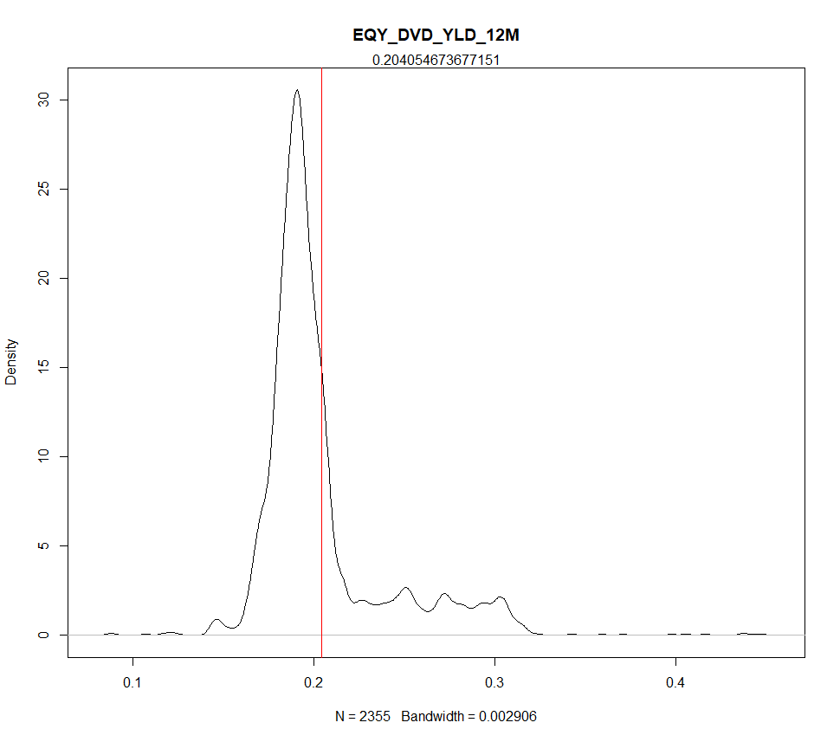

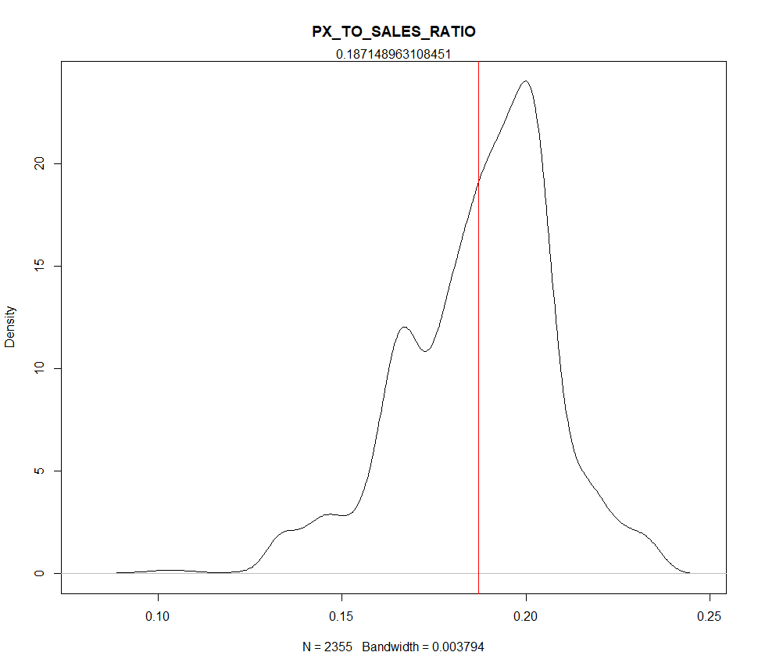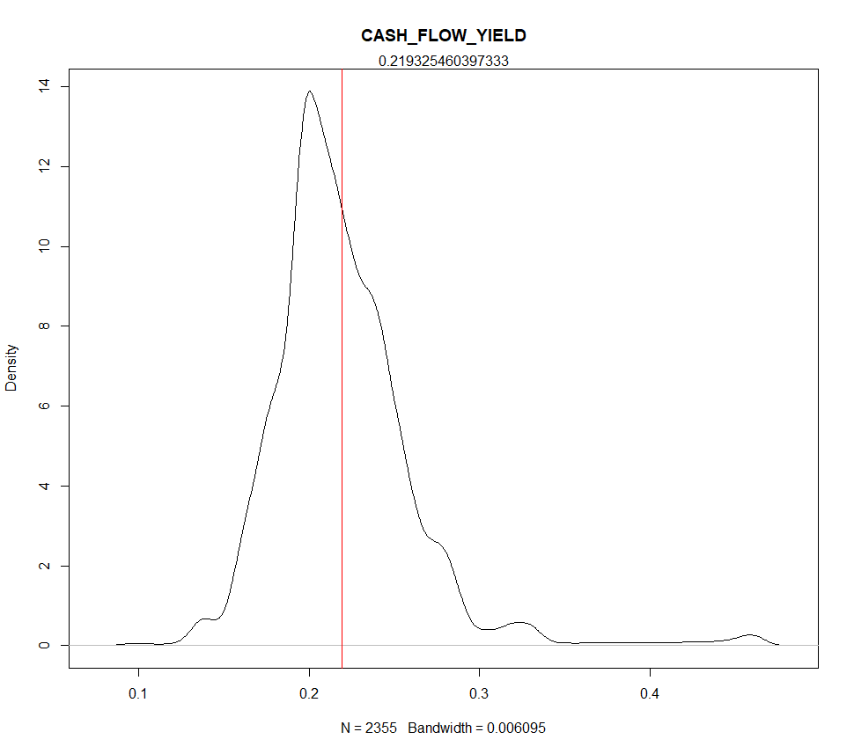

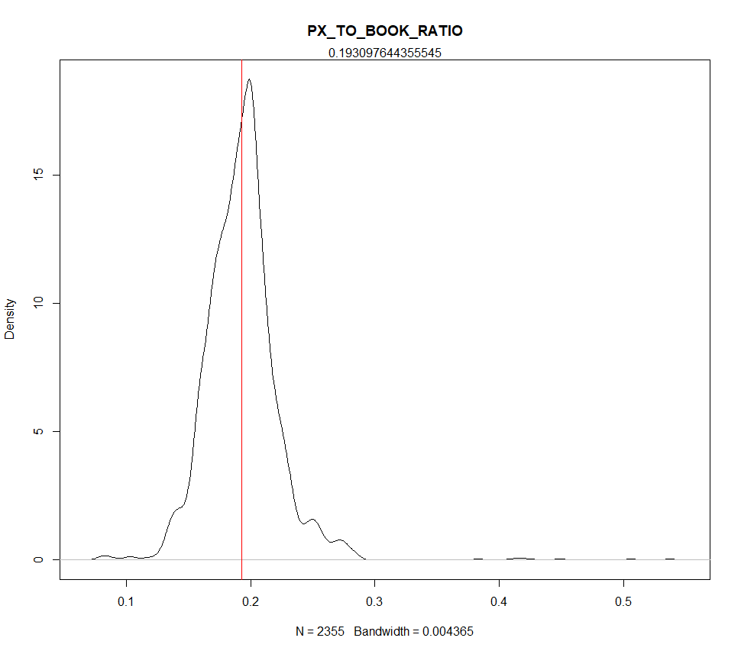

# Using all 5 Value factors

Forecasted 22 working days (1 month). *Dividends not considered. 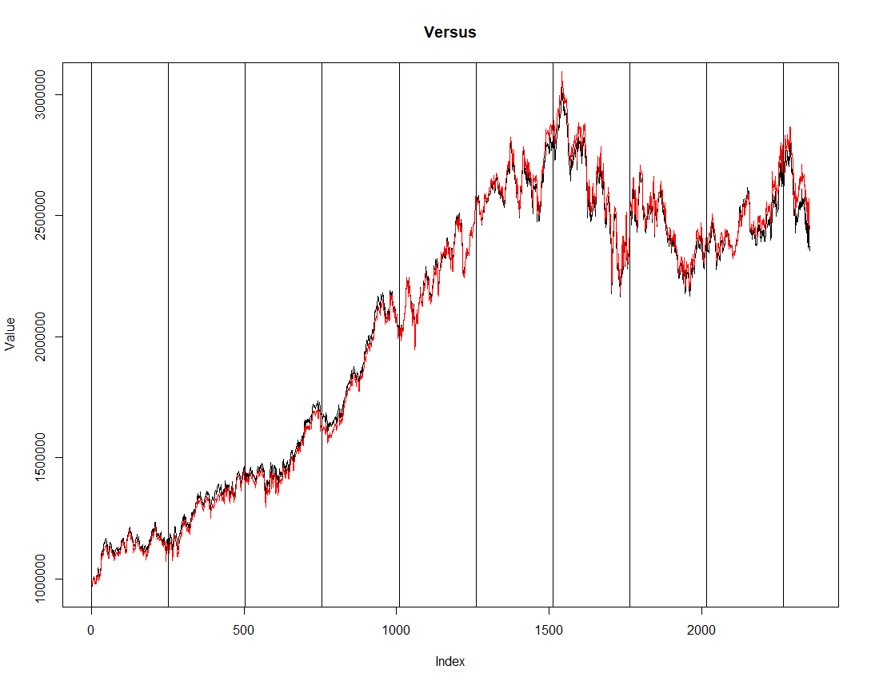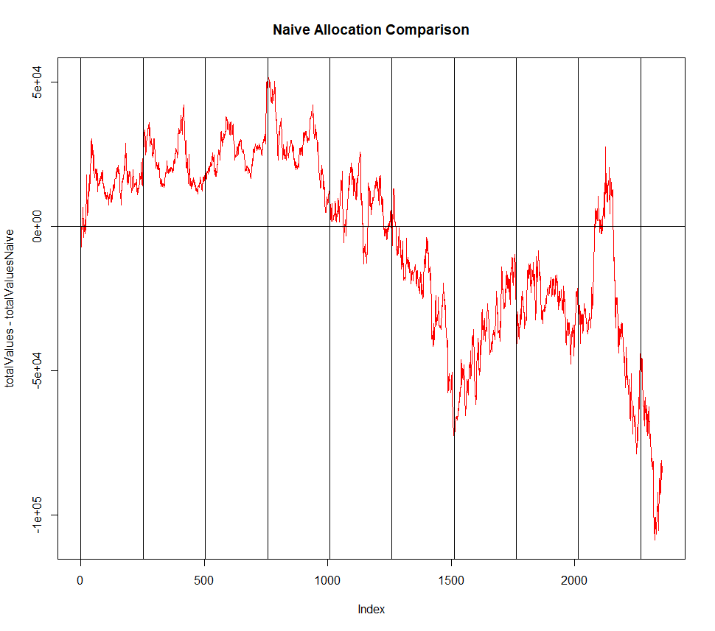

Naïve volatility is 0.4% **higher**.

# Using only Earnings Yield and Dividend Yield

*Dividends not considered. 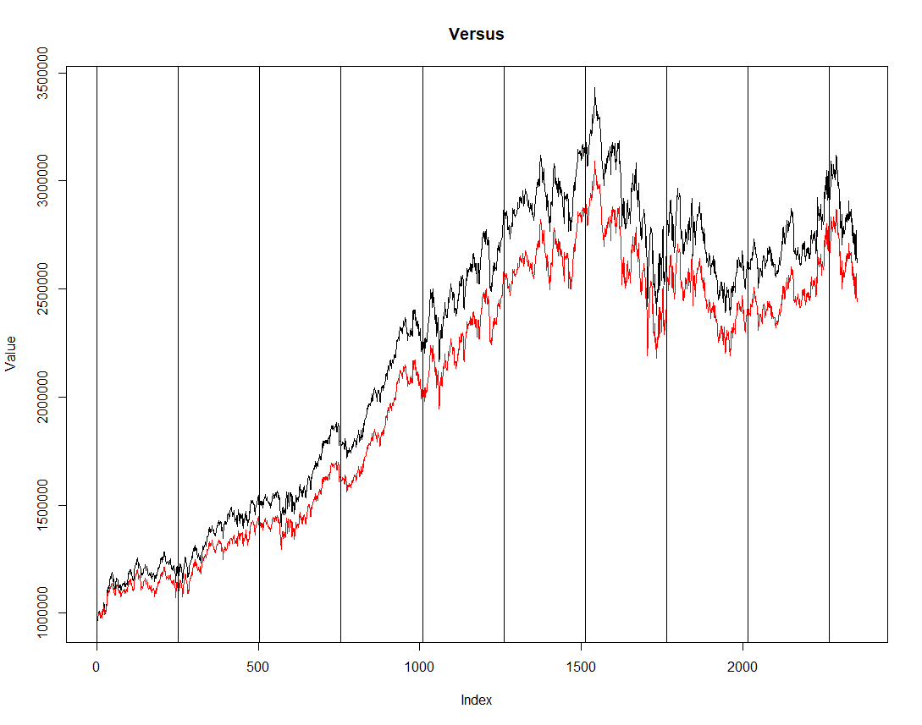

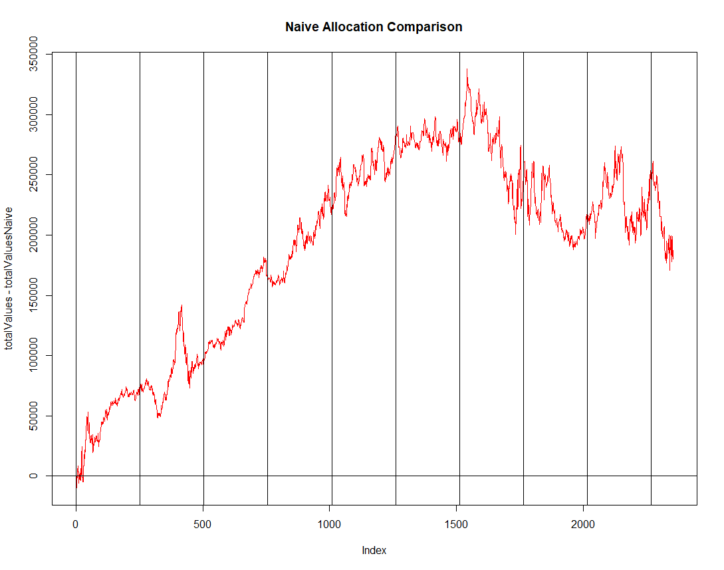

Naïve volatility is 2.6% **lower**.

# Allocation using only Dividend Yield

*Dividends not considered.

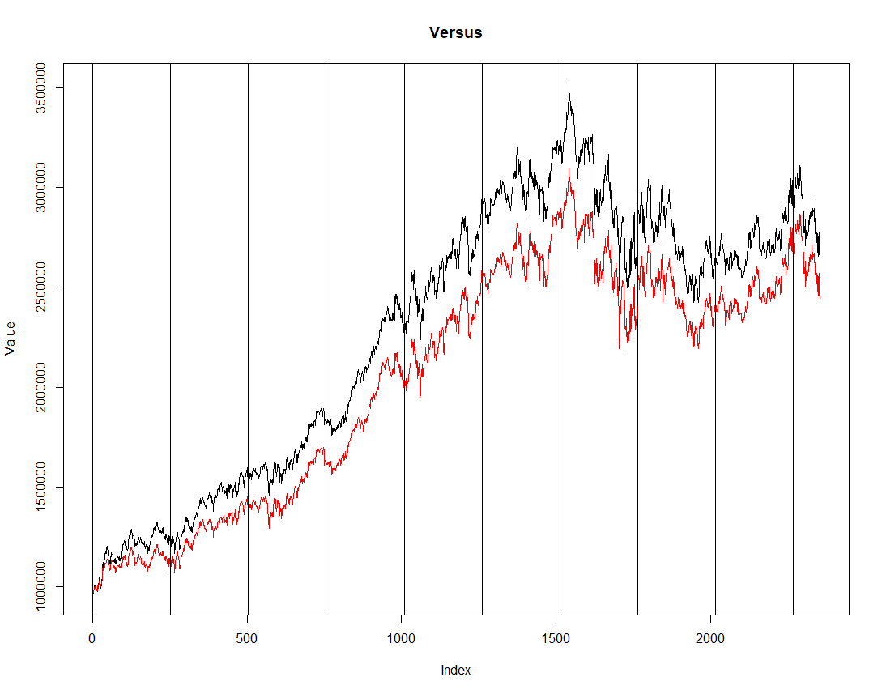

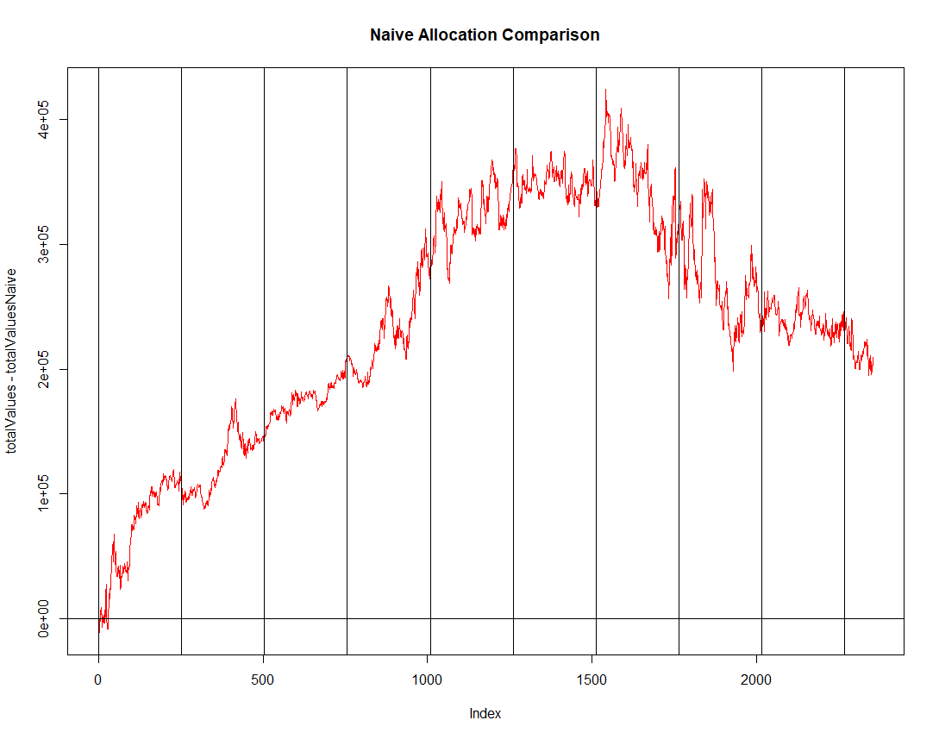

Naïve volatility is 3.2% **lower**.

# Allocation using only Earnings Yield

*Dividends not considered.

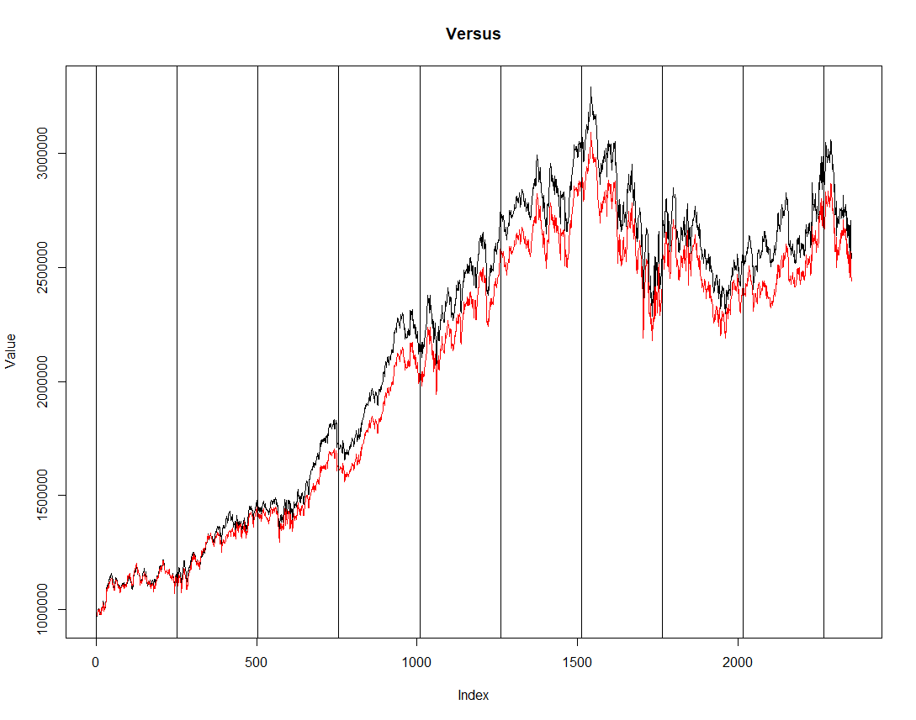

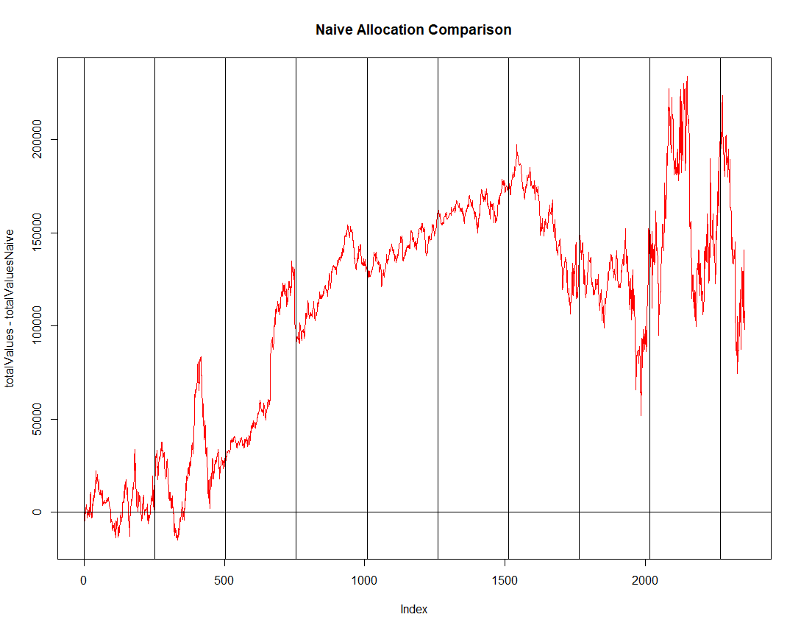

Naïve volatility is 3.4% **lower**.

# Example allocations

